**Docker Image url and Commands to run the image from docker hub :**

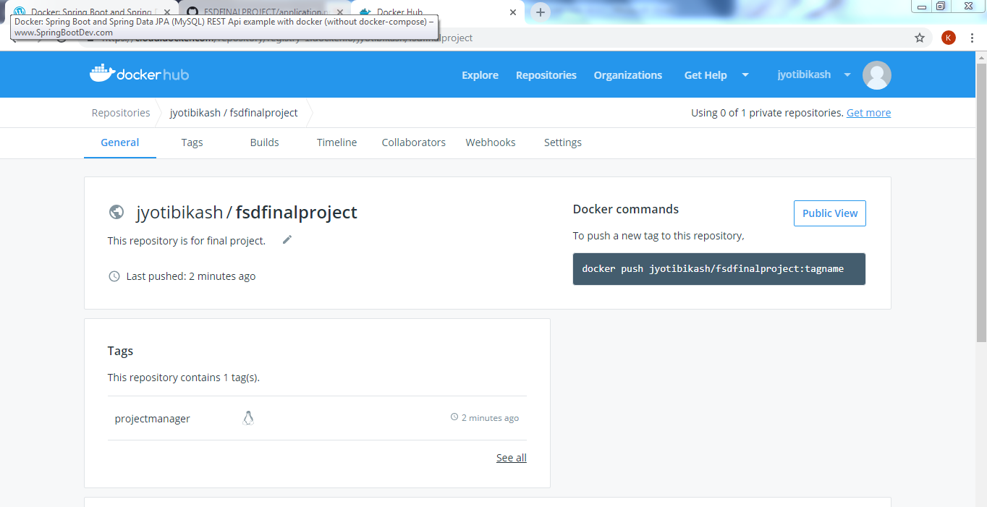

* Pull the app image from docker cloud :  
  **docker pull jyotibikash/fsdfinalproject:projectmanager**
* Then Run the command : **docker run -t --name projectmanager-container -p 8084:8084 jyotibikash/fsdfinalproject:projectmanager**
* See log and hit URL to check application [**http://localhost:8084/**](http://localhost:8084/)